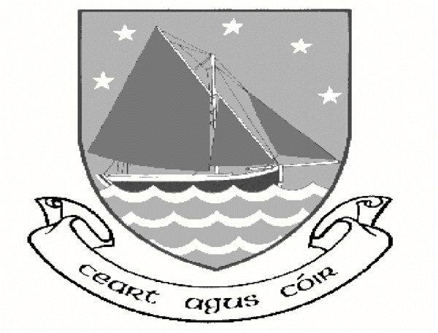 | SEPA DIRECT DEBIT MANDATE  Comhairle Chontae na Gaillimhe  Galway County Council  This form is also available in large print.  Tá míle fáilte romhat an fhoirm seo a líonadh i nGaeilge  agus tá leagan Gaeilge den fhoirm seo ar fáil chomh maith.
*Unique Mandate Reference

*Creditor Identifier |  | IE09ZZZ300861
Legal Text: By signing this mandate form, you authorise (A) Galway County Council to send instructions to your bank to debit your account and (B) your bank to debit your account in accordance with the instructions from Galway County Council.
As part of your rights, you are entitled to a refund from your bank under the terms and conditions of your agreement with your bank. A refund must be claimed within 8 weeks starting from the date on which your account was debited. Your rights are explained in a statement that you can obtain from your bank.
Please complete all the fields below marked *

*Your Name
*Your Address
*City/Postcode |  |  | *Country
*Account No (IBAN)
*Swift BIC No
*Creditor Name | GALWAY COUNTY COUNCIL
*Creditor Address | FINANCE DEPARTMENT ARAS AN CHONTAE
*Creditor Address | PROSPECT HILL
 | GALWAY
*Country | IRELAND

Type of Payment: Recurrent: or One-Off Payment: (Please tick √)

*Signature/s: |  | *Date of signing:
*Frequency: (Please tick √) - RATES
Monthly: Bi-monthly Half yearly Yearly

*Customer Telephone number: *E-mail:

Galway County Council – Contact Details
CONTACT: Rates Department.
TELEPHONE NO: (091) 509184/217/174
E-MAIL: rates@galwaycoco.ie WEBSITE: www.galway.ie

